Algebra Objective 4-1 — Identifying Linear Functions
OBJECTIVES
I can identify a linear function from its graph.
I can identify a linear function from a table of ordered pairs.
I can identify a linear function from its equation.
REAL LIFE USE:
FINANCE — A car that loses the same amount of value every year drops along a straight line, because the rate of change stays constant. Linear functions model any steady, constant-rate situation, like earning a fixed wage per hour.
Vocabulary
Linear Function
A ____________________ is __________________________________________.
Example: Identify each graph as a Linear or Non-Linear Function.
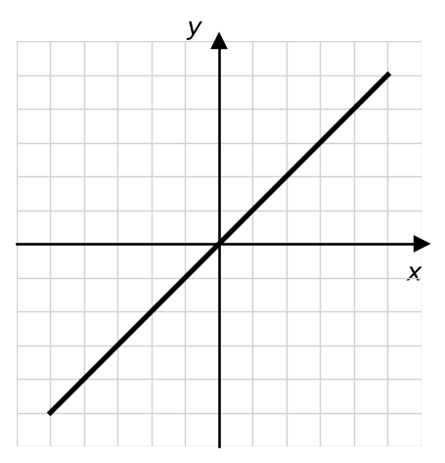  Linear Function | 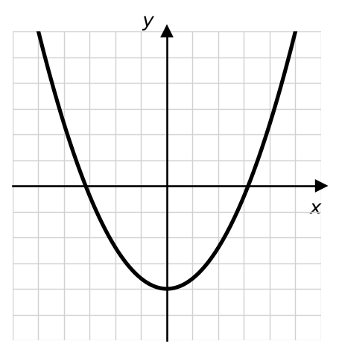  Non-Linear Function
Identifying Linear Functions by Ordered Pairs (X-Y Tables)
To tell whether ordered pairs form a linear function, check for a __________________ (constant pattern)
in both the x-values and the y-values.

Linear Function  x increases by +4 and y by +3 — a constant rate of change. | Non-Linear Function  The y-values do not change by a constant amount.
  X | Y
  0 | -3
  4 | 0
  8 | 3
  12 | 6
  X | Y
  -4 | 13
  -2 | 1
  0 | -3
  2 | 1
Identifying Linear Functions by Graphing
Make a table of values for each equation. If the points form a straight line, it is linear.
1. x = 2y + 4  Linear or Non-Linear? __________ | 2. xy = 4  Linear or Non-Linear? __________
  X | Y
  X | Y
Lesson Summary
A linear function has a constant rate of change, so its graph is a straight line. You can identify a linear function three ways: its graph is a straight line, its table has a constant change in x and a constant change in y, and its equation can be written so x and y are to the first power (no products like xy or powers like x squared).
Key Takeaways
• A linear function graphs as a straight line.
• In a table, both x and y change by a constant amount.
• Equations like xy = 4 or x squared are NOT linear.

